Money Follows the Person Demonstration (MFP Demo) Business Rule

Revision History
Date | Version | Description | Author
July, 2026 | 1.2 | Addition of SCO as a Case Management Entity, Case Management Reassignment Process and Reporting responsibilities; change to MFP Demo referral email address, MFP-IS Data Entry Requirements, pre and post transition tasks, Approval and Payment of Demonstration Activities, change to Journal Note Requirements, name change MBY, and AGE rebranding. | AGE
July 11, 2024 | 1.1 | Addition of E-invoicing Details | AGE
June 21, 2024 | 1.0 | MFP Demo Relaunch | AGE

Table of Contents
Money Follows the Person Demonstration (MFP Demo) Business Rule 1
MFP Demo Description and Requirements 2
MFP Demo Specific Services 3
How to Enroll Individuals or Refer to MFP Demo 4
MFP Demonstration Requirements: Transition Planning 5
MFP Demo Risk Assessment and Back Up Plan Requirements 5
MFP Demonstration Requirements: Community Tracking 6
Case Management Entity Reassignment Process 6
Data Entry Requirements for the MFP Demo 7
MFP Information System (MFP-IS) and Data Entry Requirements 7
Aging & Disability MFP Demo Requirements 9
Creating the MFP Demo Care Enrollment 9
Terminating the MFP Demo Care Enrollment 10
Activities & Referrals Options 12
Journal Note Requirements 12
File Attachment Requirements 13
Service Deliveries for MFP Demo Billing 14
Creating an MFP Demo Service Delivery 14
Approval and Payment of MFP Demonstration Activities 16
Reporting Responsibilities 17
Critical Incident Reporting 17
AGE Contacts 18

MFP Demo Description and Requirements
The Money Follows the Person Demonstration (MFP Demo) was launched August 2023 with the Aging Service Access Point (ASAP) network. The MFP Demo does not pertain to the MassHealth Moving Forward Plan (MFP) Waivers. This Business Rule and program supersedes and replaces any former guidance and program.
The MFP Demo is a Center for Medicare and Medicaid Services (CMS) federally funded demonstration grant that helps older adults and individuals with disabilities transition from nursing facilities, chronic disease or rehabilitation hospitals, or other qualified facilities back to the community. MFP Demo services are arranged for the MFP Demo enrollee by the MFP Demo Case Manager through one of the four approved Case Management Entities:
- Aging Service Access Points (ASAPs)
- Department of Developmental Services (DDS)
- MassAbility (MBY)
- Senior Care Options (SCO)

MFP Demo includes structured case management for 365 days in a qualified community setting following discharge from a nursing facility, chronic disease or rehabilitation hospital, or other qualified facility.
To qualify for the MFP Demo, a person must meet all the following criteria:
- An eligible MassHealth Standard or CommonHealth member or meet financial criteria to qualify and
- Living in a qualified nursing facility or long-stay hospital for at least 60 consecutive days, including Medicare rehabilitation days and
- A resident of Massachusetts
- 18 years old or older and be disabled, or be age 65 or older,
- Transition to an MFP Demo qualified residence in the community
MFP Demo qualified community residences include:
- A home owned or leased by the MFP Demo enrollee or a family member
- An apartment
- A community-based setting where no more than four unrelated people live
- An assisted-living apartment with separate living, sleeping, bathing, and cooking areas; lockable doors; and other features

An individual’s eligibility and enrollment in any of the Home and Community-Based Service (HCBS) Waiver programs does not impact an individual's enrollment into the MFP Demo. For individuals who are not eligible for a HCBS Waiver program, MFP Demo can offer the individual services to which they would not otherwise have access.

The MFP Demo identifies two classifications of individuals, known as enrollees and participants:

- An Enrollee in the MFP Demo is an individual who:
  - Has signed an informed consent form
  - Resides in qualified facility
  - Is in a pre-transition (pre-discharge) phase
- A Participant in the MFP Demo is an individual who:
  - Has transitioned out of a qualified facility
  - Has transitioned to a qualified community setting
  - Is in a post-transition (post-discharge) phase

MFP Demo Specific Services
MFP Demo provides three categories of services and supports that help older adults and individuals with disabilities move from facility-based care back to the community. These services include:

- Transitional Assistance (TA) - Non-recurring set-up expenses and short- term services necessary to facilitate a person’s transition from a facility- based long term care setting to the community. Examples of TA include, but are not limited to:

  - Finding accessible and affordable housing
  - Paying for moving expenses
  - Paying for security deposits, utility deposits, and first month’s
rent
  - Purchasing home furnishings
  - Improving accessibility through home and vehicle modifications
  - Providing peer support
  - Purchasing assistive technology devices
  - Providing case management and help with linking you to other available services

- Assistive Technology (AT) - Devices, controls, or appliances that enable a person to increase their ability to perform activities of daily living. Examples of AT include, but are not limited to:

  - Communication boards
  - Speech amplifiers
  - Electronic device that produces speech or written output
  - Voice-activated or remote environmental control unit
  - Specialized door opener
  - Customized iPad
  - Specialized alarms

- Community Engagement Navigation (CEN) - A “bridge” service that would include accompaniment and transportation from facilities to community housing and service options; supporting service exploration and linkage; and assistance with connections to and engagement with community services.

How to Enroll Individuals or Refer to MFP Demo
Individuals who desire to transition to the community have access to the MFP Demo and can be referred by anyone or enrolled by an approved Case Management Entity if the eligibility criteria outlined above are met. There are no clinical eligibility requirements for the MFP Demo.

Individuals who are serviced through other programs focusing on transitions out of nursing facilities such as Community Transition Liaison Program (CTLP) or Home Care and who meet qualifications should be enrolled in MFP Demo.
For individuals requesting to enroll in the MFP Demo, an MFP Demo Informed Consent Form must be completed and signed by the individual. The individual must be entered into MFP-IS within 5 business days of the date of the signed Informed Consent Form. ASAP staff must keep copies of the MFP Demo Informed Consent Form and other related program forms in the consumer’s record.

To Enroll - ASAP staff should only have the Informed Consent Form signed for any individual age 60 or older and enter the individual in MFP-IS as they will be completing required MFP Demonstration Case Management pre-transition tasks for the consumer and will be the assigned Case Management Entity.

Note: The Informed Consent Form should be uploaded to file attachments in A&D.

To Refer - If the ASAP staff will not be completing the required MFP Demonstration Case Management pre-transition tasks and serve as the assigned Case Management Entity, only the MFP Demonstration Referral Form should be completed and emailed to the MFP Project Office (MFP@mass.gov). An Informed Consent Form should not be completed if ASAP staff are making a referral only.

For more information, please refer to the MFP Demo Workflow for referrals and enrollments in the MFP Demo.

MFP Demonstration Requirements: Transition Planning
MFP Demo Case Managers are responsible for:
- Supporting and assisting all enrolled individuals transitioning into the community
- Providing information about the range of community-based services, supports, and housing options
- Facilitating a person-centered planning process which includes identifying housing options, determining, arranging, and authorizing services needed to ensure a safe transition
- Conducting a risk assessment and working with the individual to develop an appropriate back-up plan, responsive to the individual’s needs and risks.
- Assist with completing any applications that will help an individual maintain MH eligibility in the community
- Updating MFP-IS to reflect the enrollee transition
- Confirming Status Change (SC-1) form was submitted from Nursing facility to MassHealth
- Confirming Consumer is transitioned to the community with MassHealth Standard or CommonHealth, and if necessary, assist with completing any needed paperwork
- Completing the necessary updates in the MFP-IS system from enrollee to participant.
- Conduct a warm transfer with the receiving CM Entity

MFP Demo Risk Assessment and Back Up Plan Requirements
The risk level for MFP Demo enrollees and participants should be classified as a Risk level 1 or 2 utilizing AGE’s Risk Level Assessment Worksheet.

Prior to the nursing facility transition, ASAP staff are required to complete the Risk Assessment Form, which serves as the back-up plan, and detail date of completion within the MFP-IS system. The Risk Level Assessment Worksheet and Risk Assessment Form are to be completed in accordance with requirements for Risk Level 1 or 2 outlined in PI 11-06 Risk Management.
The back up plan must include 24-hour back-up system including:
- Critical services
- Transportation
- Direct care workers
- Repair and replacement of Durable Medical Equipment (DME)

- Access to medical care, including:
- Assistance with initial appointments
- How to make appointments
- Resolving appointments or care issues
The risk assessment worksheet and back up plan must be completed prior to transition and uploaded to the consumer record as a file attachment in A&D for the ASAP to submit a service delivery.

MFP Demonstration Requirements: Community Tracking

Following the successful transition of the Participant to the community, the ASAP staff will begin tracking for 365 days.
ASAP staff will be responsible for completing the following actions:
- Monitoring the back-up plan, service provisions and adjusting as needed for 365 days in the community.
- Tracking the Consumer’s 365 days of community tenure, pausing and extending for any instance the Consumer leaves the community.
- Entering Events into MFP-IS if the Consumer has another transition of care to a hospital or nursing facility to pause the 365-community day count.

Days that are spent in a facility following the transition to the community will be added to the 365-day tracking length. Days spent outside of a community setting will not count towards the 365-day tracking requirement of community tenure. For example, if a consumer has spent 10 days in a hospital following their transition to the community, the total tracking will be 375 days (365 days + 10 hospitalization days).

In addition to documentation in A&D and data entry in MFP-IS at initial discharge, ASAP staff are required (if the assigned Case Management entity) to continue tracking the Consumer 365 days post discharge. ASAP staff must identify any interruptions from the community stay (ex: Hospitalization) by updating the MFP-IS system and documenting accordingly in the A&D Journal.

Case Management Entity Reassignment Process

During both pre-transition and post-transition phases there may be circumstances where the CM entity must be changed and the ASAP will no longer be overseeing the individual’s transition or providing MFP Demo Case Management.

An MFP Demo enrollee or participant may be reassigned if they:
- move to a different nursing facility outside of the ASAP’s catchment area
- transfer to another ASAP’s catchment area
- become approved for a HCBS Waiver
- enroll into a One Care, PACE or SCO plan
- enroll in state plan services only (PCA, AFC, GAFC)
- disenroll from a Home Care Program

When an MFP Demo individual has an event from the list above, do not reassign the individual in MFP-IS to another case management entity or ASAP. Instead, email the MFP Demo Project Office at mfpprojectoffice@mass.gov to request reassignment.

Upon receiving a request for reassignment, the MFP Demo Project Office will:
- Outreach to the new case management entity to confirm who will be the new case manager for the individual
- Update MFP-IS and reassign the individual from one case management entity to the other
- Send a warm transfer email requesting the:
  - original and new case managers connect and share information,
  - new case manager complete outstanding tasks,
  - new case management entity assigns the case manager in MFP-IS within 5 business days.

By connecting the original and new case management entities, collaboration is fostered and a smooth transfer of case management is ensured for the MFP Demo enrolled individual.

Data Entry Requirements for the MFP Demo
Data entry requirements for the MFP Demo consists of entry and documentation in two database systems:
  - Money Follows the Person Information System (MFP-IS) is the database used by all Case Management Entities for enrollment, case management assignment, and transition events.
  - Aging and Disability (A&D) for monitoring and invoicing.
Each system requires separate details to be entered as highlighted in the following sections.

MFP Information System (MFP-IS) and Data Entry Requirements
Money Follows the Person Information System (MFP-IS) is the MFP Project Office central system of record to provide a state-wide information service through a network of agencies in support of the MFP Demonstration.

To gain access to MFP-IS, ASAP staff shall:
- Submit a User Request Form (URF) to the MFP Project Office via email
- The URF must be sent by the designated Access Administrator at the ASAP to identify ASAP staff that need access to MFP-IS and what role should be assigned to each staff member. The different roles in MFP-IS are as follows:

- Agency Observer: This role allows designated users to have view-only access to all MFP Enrollee and Participant records managed by their agency/entity.
- Resource Management: This role allows designated users the ability to reassign an MFP Enrollee or Participant to another state agency/entity. Users with this access will also have access to functionality to assign a case manager. No additional functionality is assigned to this role.

- Agency Program Staff: This role allows designated users the ability to view and manage MFP Enrollees and Participants entered and managed by their agency/state entities case managers.
- Case Manager: This role allows the designated users to enter and manage MFP Enrollee and Participant records. Users with this role will only have access to their records, and not the agency data.

When there is a case manager change for an individual enrolled in the MFP Demo, ASAP staff with an MFP-IS Program Staff role must do the following within 5 business days of the change:

- Run the MFP-IS MassHealth Eligibility Assessment and Verification Status Report to identify all the MFP Demo individuals currently assigned to that case manager.
- Update MFP-IS by selecting a new case manager for each MFP Demo individual.
If the new case manager is not listed in the MFP-IS dropdown menu, email the MFP Demo Project Office at mfpprojectoffice@mass.gov and request that the case manager be added. Please provide the case manager’s name, email address, and phone number.

- If the case manager is no longer employed by the ASAP, and after all their assigned MFP Demo individuals have been updated to a new case manager in MFP-IS, email the Project Office at mfpprojectoffice@mass.gov to share information that the case manager has left and request removal of the individual from the MFP-IS case manager dropdown list. Then submit an MFP User Request Form (URF) to deactivate the previous case manager.

ASAP staff must adhere to documentation requirements and data entry requests made by the MFP Demo Project Office and AGE. If the ASAP is the Case
Management Entity for MFP Demo, required documentation in MFP-IS includes, but is not limited to:
- Enter new enrollees
- Manage existing enrollees and participants
  - Assign an ASAP Case Manager
  - Enter community transition date
  - Enter dates of completed risk assessment & backup plan
  - Enter readmission or hospitalization events
  - Track 365-day program enrollment
  - If transition is no longer the goal, enter the withdrawal information in the events tab
- Manage eligibility statuses
- View and Print reports

For utilization and data entry specific to the MFP-IS system, please refer to the MFP-IS user guide located within the MFP-IS system.

Aging & Disability MFP Demo Requirements

Creating the MFP Demo Care Enrollment
The ASAP providing MFP Demo Case Management creates a Money Follows the Person Demonstration (MFP Demo) Care Enrollment for each consumer who provides MFP Demo case management and service coordination. A Care Enrollment should not be created if a referral was made. A new Care Enrollment is entered into A&D for all consumers enrolled in the MFP Demo regardless of enrollment in other Home Care programs. An MFP Demo Care Enrollment should only be completed after the individual has signed the Informed Consent Form.

If there are multiple ASAPs involved with an individual for the MFP Demo, each ASAP must open, manage, and close their own individual MFP Demo Care Enrollment.

- The Money Follows the Person (MFP Demo) Care Enrollment in A&D includes:
- Level of Care = MassHealth Programs
- Service Program = Money Follows the Person Demonstration (MFP Demo)
- Care Program = Money Follows the Person Demonstration (MFP Demo)
- Application Date = Date of signed Informed Consent Form
- Received Date = Date of signed Informed Consent Form
- Termination Date = Blank while the ASAP staff is actively working with the consumer
- Status = Active while the ASAP staff is actively working with consumer
- Reason = Blank while the ASAP staff is actively working with the consumer
- Status Date = Date of signed Informed Consent Form
- Start Date = Date of signed Informed Consent Form
- End Date = Leave Blank while the ASAP staff is actively working with consumer

Example of new Care Enrollment
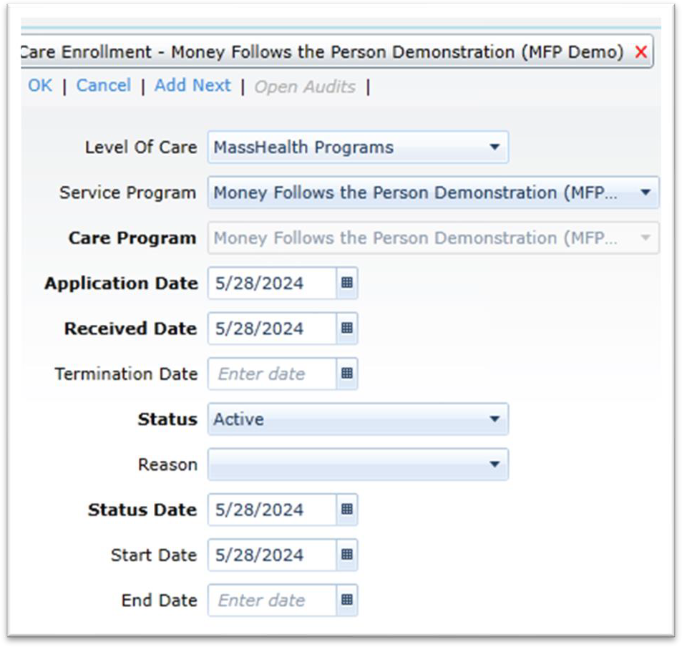

Terminating the MFP Demo Care Enrollment
The ASAP will terminate the MFP Demo Care Enrollment when the individual:

- MFP Demo – Withdrawn from Demo: is no longer interested in the MFP Demo, no longer interested in or able to complete the discharge to the community, and signs a Withdrawal Form.
- MFP Demo – Ineligible for Demonstration: no longer meets eligibility requirements for the MFP Demo including, but not limited to, transitioning to a non-qualified community residence as outlined above.
- MFP Demo – Transferred CM Entity: is transferred to another MFP Demo Case Management Entity (Another ASAP, MBY, SCO or DDS),
- MFP Demo – 365 Participation Complete: has completed 365 days in the community

- MFP Demo – Death: passes away
Data entry for the termination of the MFP Demo Care Enrollment:
  - Level of Care = MassHealth Programs
  - Service Program = Money Follows the Person Demonstration (MFP Demo)
  - Care Program = Money Follows the Person Demonstration (MFP Demo)
  - Application Date = Date of signed Informed Consent Form
  - Received Date = Date of signed Informed Consent Form
  - Termination Date = Date the consumer is being terminated from the MFP Demo
  - Status = Terminated
  - Reason = Choose from one of the termination reasons notated above
  - Status Date = Date of signed Informed Consent Form
  - Start Date = Date of signed Informed Consent Form
  - End Date = Date the individual terminated from the MFP Demo

Example of a terminated Care Enrollment. Note: A termination reason needs to be selected.
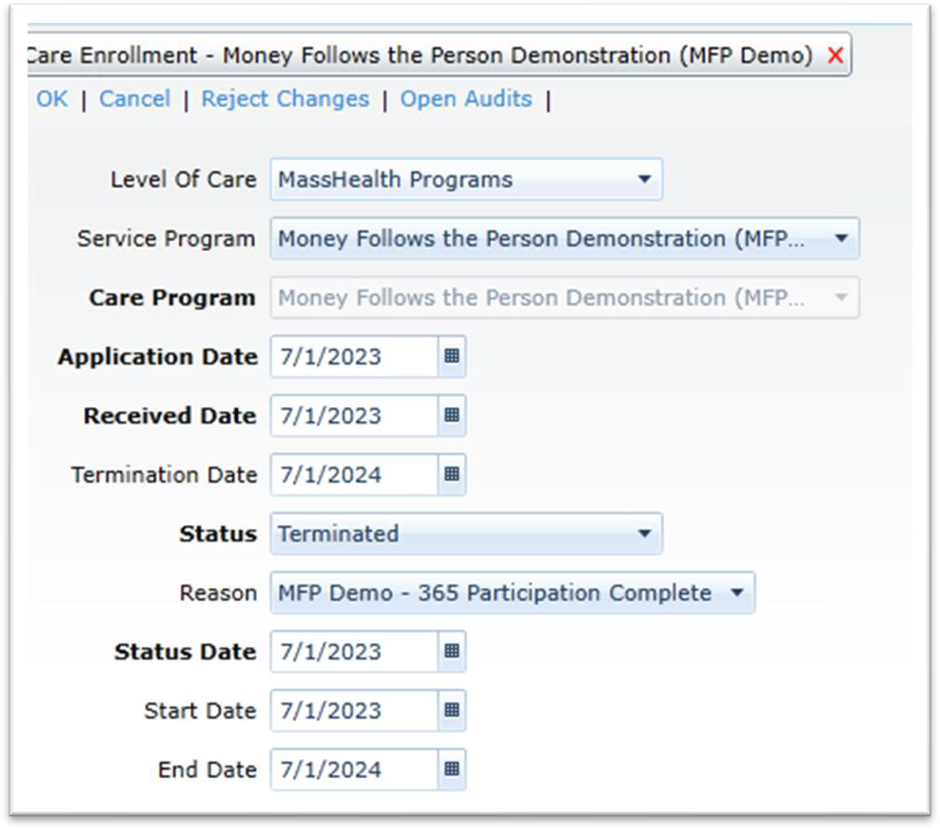

Activities & Referrals Options
All MFP Demo Activities and Referrals are optional tracking tools for ASAPs to use as needed. ASAPs that choose to utilize optional MFP Demo actions must create:
- utilization procedures for MFP Demo actions
- procedures must include direction on entering and terminating,
- reporting procedures for monitoring and tracking actions to ensure actions are terminated and utilized according to the ASAP procedure(s)

ASAPs are responsible for ensuring good data hygiene on all MFP Demo actions the ASAP chooses to utilize.

Available Actions:

- MFP Demo – Follow-up
This Activity & Referral can be used to track any necessary MFP Demo related follow-up.
- MFP Demo – Service Referral Tracking
This Activity & Referral can be used to track and monitor the status of MFP Demo specific service (TA, AT, CEN) referrals.
- MFP Demo – 365 Day Tracking
ASAP staff are required (if the assigned Case Management entity) to continue tracking the Consumer 365 days post discharge. This Activity & Referral can be used to track the date a consumer has completed their 365 days in the community and the Money Follows the Person Demonstration (MFP Demo) Care Enrollment should be terminated. This date can also be found in the MFP-IS system.
- MFP Demo – Participation Suspended
ASAP staff must identify any interruptions from the community stay (ex: Hospitalization or SNF readmission) by updating the MFP-IS system and documenting accordingly in the A&D Journal. This Activity & Referral can be used as a tool to track when the MFP Demo community day count is paused.

Journal Note Requirements
Documentation in the consumer record shall include at a minimum:
- Any and all contacts with the consumer, facility staff, support or stakeholders and the purpose of each contact
- Any and all Interdisciplinary Case Conferences
- Any assessment of the consumer, including functional assessment, and identified needs
- Any care planning and discharge planning preparation, planning and steps
- Any identified services, service plans, referrals or supports involved

All journal notes shall be comprehensive and demonstrate that there has been support provided to an individual as it relates to services offered through the MFP Demonstration both pre-transition and 365 days once the individual has returned to a community setting.

The following two journal notes are optional when the described events occur:

- MFP Demo - 24 Hr Back Up Plan Utilization – Use for calls received by MFP Demo participants for emergency backup assistance and the type of assistance needed.
Emergency refers to situations that could endanger the health or well-being of a participant and may lead to a critical incident if not addressed. This does not include informational calls or calls pertaining to complaints. Calls in this category include:
- Transportation to get to medical appointments
- Life-support equipment repair/replacement
- Critical health services
- Direct service/support workers not showing up
- Other (to be detailed within the journal note)

- MFP Demo – Critical Incident Reported - Use when ASAPs report a Critical Incident to AGE utilizing the Critical Incident Reporting Portal. The Journal Note reflects that the incident has been submitted to AGE.

File Attachment Requirements
Documents for MFP Demo are required to be uploaded into the File Attachment section in the folder called Money Follows the Person (MFP). The three sets of documents required to be uploaded into the consumer record are below and should be named as such in the Description section of the File Attachment:

  - Informed Consent Form –
    - The naming convention in the Description should be titled MFP Demo Informed Consent Form
  - Referral Form –
    - The naming convention in the Description should be titled MFP Demo Referral Form
  - Withdrawal Form –
    - The naming convention in the Description should be titled MFP Demo Withdrawal Form
  - Risk Assessment & Back Up Plan –
    - Both the Risk Level Assessment Worksheet and Risk Assessment Form must be uploaded.
    - Description of the file should have standard naming convention titled {ASAP Abbreviation} + MFP Demo Risk Assessment & Back Up Plan.
    - Example: TVES MFP Demo Risk Assessment & Back Up Plan A & D screen shot of File Attachment:

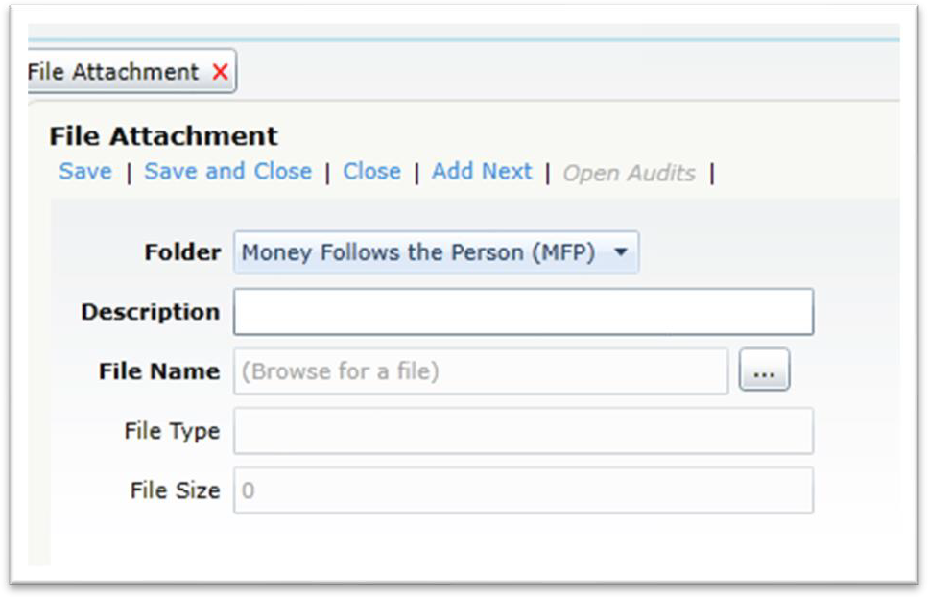

Service Deliveries for MFP Demo Billing

Creating an MFP Demo Service Delivery

The ASAP providing MFP Demo Case Management creates a service delivery that matches the services being provided. There are 5 service delivery types to choose from:

  - MFP Demo – Consent & Enrollment
  - MFP Demo – Transition Planning – Full
  - MFP Demo – Transition Planning – Partial
  - MFP Demo – Community Tracking – 365
  - MFP Demo – Enrolled/Participation prior to FY27

- Data Entry for the service delivery
- Care Program = Money Follows the Person Demonstration (MFP Demo)
- Agency = ASAP Name
- Provider = ASAP Name
- Service Category = Money Follows the Person Demonstration (MFP Demo)
- Service = Choose appropriate service delivery type
- Service Month/Year = The month in which the event occurred

- Units= 1.0

Example of a Service Delivery:
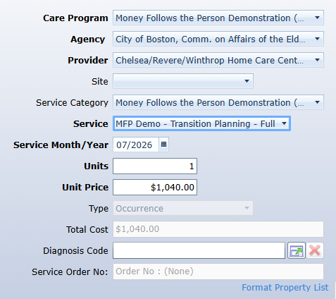
Note: ASAPs cannot enter a Service Delivery under another ASAP’s Care Enrollment.

MFP Demo Consent & Enrollment
Once the ASAP has confirmed all required consent & enrollment steps listed above have been completed, a Service Delivery should be entered in the Consumer’s record within 30 days for the Consent & Enrollment.

MFP Demo – Transition Planning -Full
Once the ASAP has confirmed all required transition planning steps above have been completed and the individual has transitioned to a community setting, a Service Delivery should be entered in the Consumer’s record within 30 days for the Transition Planning – Full payment.

MFP Demo – Transition Planning – Partial
An ASAP would be eligible for a partial payment if the record shows that the ASAP supported the individual with any of the transition planning tasks above and the following happens:
  - The individual withdraws from the Demonstration
  - Transfers to another CM entity prior to transitioning to the community
  - Transfers to your ASAP prior to transitioning to the community
  - Death
Note: A service delivery should be entered during the month in which the event occurs.

MFP-Demo – Community Tracking – 365
Once the ASAP has confirmed that the individual has been determined an “active” Participant in MFP-IS for the Demonstration and the ASAP will be the CM Entity for 365 days in the community, a Service Delivery should be entered in the Consumer’s record Community Tracking – 365. The post-transition Service Delivery may be entered prior to the MFP Demo Participant’s completion of the full 365-day community period.

MFP Demo – Enrolled/Participation prior to FY27
A service delivery for an individual who enrolled into the Demonstration prior to FY27 (7/1/2026) can be entered for both enrollment & transition when the following guidelines are met.
- Enrollment:
- MFP-IS record has been created.
- MFP Informed Consent was signed and recorded in MFP-IS system.
- Informed Consent was uploaded to file attachments in A&D
- MFP Care Enrollment was created in A&D
- Transition:
- Risk Assessment/Back up plan has been completed.
- Consumer is confirmed to be transitioned out of the facility to a qualified setting to the community
- SC-1 form has been submitted and status updated to community.
- MFP-IS system has been updated with date of discharge.
- MFP-IS reflects that the consumer is an Active Participant
Note: ASAPs cannot enter a Service Delivery under another ASAP’s Care Enrollment.

Approval and Payment of MFP Demonstration Activities

Once the service delivery has been completed and it is acknowledged that all necessary steps outlined above have been completed, the ASAP will then use the E-invoicing system to generate an invoice.

The ASAP can submit the Invoice by following these steps:

The Agency Approver (E-invoicing role) will first create the invoice:
- Click Create Invoice on the E-invoicing home page
- Click Create SIMS Invoice
- Select the desired MFP Demo invoice
- Confirm it matches the Service Deliveries for the month being submitted
- Attach the supplemental MFP Demo E-invoicing Spreadsheet
- Click Submit to move the E-invoice to the approval stage

The Agency Approver can then move to approve the invoice:
- Click My Invoices on the E-invoicing home page
- Locate the desired MFP Demo invoice to review and select view under the Commands column
- Review the invoice and click Approve if accurate to be submitted to AGE for review.
  - If an error is identified during this step, Agency Approver will notify AGE staff (contacts at the end of this Business Rule) for invoice deletion.
AGE staff will identify that an invoice has been submitted and will review A&D to ensure the requirements as outlined are met prior to approving the invoice. If the requirements have not been met, the invoice will be rejected, and a notation will be made to identify next steps. The ASAP will correct the errors and re-submit.

Reporting Responsibilities

Report Monitoring:

- ASAP
  - Run Monthly, at minimum, Care Enrollment report out of HAR and ensure the following:
    - All terminations have the correct reason selected
    - MFP-IS has been updated to reflect transitions & terminations
    - Service Deliveries have been added and requirements met
  - Run Monthly, at minimum, Enrollee & Participant aging reports out of MFP-IS and ensure the following:
    - All records have the correct Case Manger listed
    - Identify any participants that have an incomplete (IC) status, and complete the Back Up plan and/or Risk Assessment
  - Complete MFP Demo Data Reconciliation every 6 months or as requested by AGE.
  - Complete MFP Demo Outreach Report every 6 months or as requested by AGE.
  - Run as needed, the MassHealth Eligibility Assessment & Verification Status Report in MFP-IS

- AGE – Quarterly and ad hoc

Critical Incident Reporting
For MFP Demo enrollees, ASAPs are required to follow the same protocol outlined in AGE’s Critical Incident Report (CIR) Instructions. When filing a CIR, the designated ASAP staff must click the box to indicate that the Consumer is enrolled in the MFP Demo among other enrolled programs.
Please see the example screenshot below:
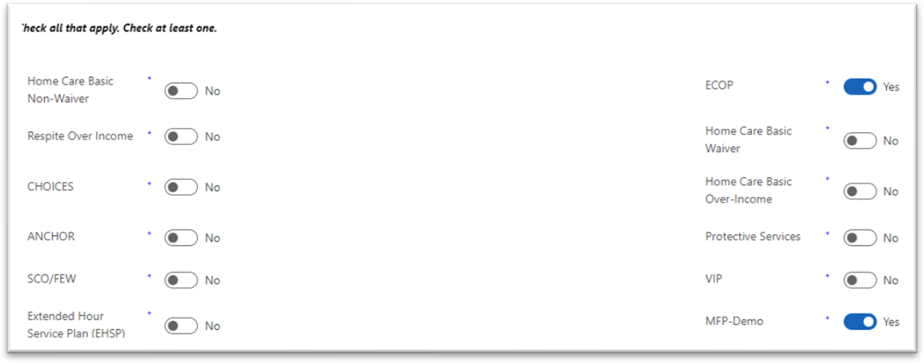

AGE Contacts
If you have questions regarding this Business Rule, please contact:

- Vanessa Medeiros, MFP Demo Coordinator at Vanessa.Medeiros@mass.gov

If you have questions regarding Advanced Reporting (AR) reporting, please contact:

- Nicholas Roberts, Home Care Data Analyst at Nicholas.P.Roberts@mass.gov

