Revision History

Table of Contents
Date | Version | Description | Author
March 31, 2026 | 1.1 | Updated Language | AGE Home Care Team
June 26, 2025 | 1.0 | Initial publication | AGE Home Care Team
Overview 1
A&D Care Enrollments in Consumer Record 1
A&D Data Entry Requirements 2
Home Care Program Waitlist Tracking: Statuses and Status Reasons 4
Reporting Requirements: 6

Home Care Priority Level Assignment and Managed Intake Tracking Overview
The Executive Office of Aging & Independence (AGE) requires all applicants enrolled into the Home Care program to have a Waitlist Care Enrollment once a priority level has been identified either through the Home Care Referral and Intake Process or the Home Care Referral Process. Waitlist Care Enrollments are used for data and reporting purposes to monitor program utilization and applicant/consumer access to the Home Care Program. Aging Service Access Points (ASAPs) are required to track new enrollments into the Home Care Program and the assigned priority level of applicants. A specific Care Enrollment, Waitlist for Home Care Basic, has been added to Aging & Disability (A&D) and shall be utilized for tracking new enrollments and assigned priority levels for all applicants of the Home Care Program. This Business Rule shows how to record data within A&D consistent with Program Instruction (PI) PI-25-05 Priority Level Assignment Process and Managed Intake

ASAPs must follow the steps outlined in this Business Rule in order for AGE to have statewide visibility of assigned priority levels and active waitlists (if applicable) for all applicants into the Home Care Program. This business practice will enable AGE to manage reallocations of Home Care Program funding to minimize the waitlist, as described in PI-25-05 Priority Level Assignment Process and Managed Intake

A&D Care Enrollments in Consumer Record:
Requirements:

- Care Enrollment: Waitlist for Home Care Basic is the care enrollment utilized to document and track the process, assigned priority levels, and outcome of the Home Care Program Referral and/or Intake Assessment. The Waitlist for Home Care Basic enrollment consists of the following data elements:
  - Status: current status of the enrollment (Detailed further in Business Rule)
  - Reason: why the enrollment is in the status chosen (Detailed further in Business Rule)
  - Status date: date the enrollment was created
  - Start date: date the applicant has enrolled onto the waitlist
  - End date the date the enrollment in the waitlist has terminated, transferred, or withdrawn

A&D Data Entry Instructions:
ASAPs must keep their A&D data as accurate and up to date as possible at all times as AGE may review waitlists at any time.

To ensure accurate reporting across the state, it is imperative that the identified data elements are entered as instructed.

Element | Values | Notes
Care Enrollment | Waitlist for Home Care Basic | Required  *only this care enrollment should be used, do not use other actions for this purpose
Status | - Waiting  - Transferred  - Terminated | Default is Active. AGE requires change of status as ASAP engages the applicant in the Home Care Program Intake process.  No other status is acceptable
Status Reasons | - Specific Status Reasons should be used for each of the appropriate Care Enrollment Statuses (Chart Below) | Default status reason is Blank. AGE requires change of status and status reason as the applicant engages in and moves through the Home Care Program Intake process.
Status Date | Date Care Enrollment is created = Date Waiting list is active | Status date is always the date AGE is basing the report time frame on.
Start Date | Date Care Enrollment is created | Required field
End Date | Date Care Enrollment is closed with appropriate status and reason | Required field

Example of a waitlist enrollment transferring to another HC program (requirement for all Home Care Applicants and completed Home Care Intakes enrolling into Home Care):

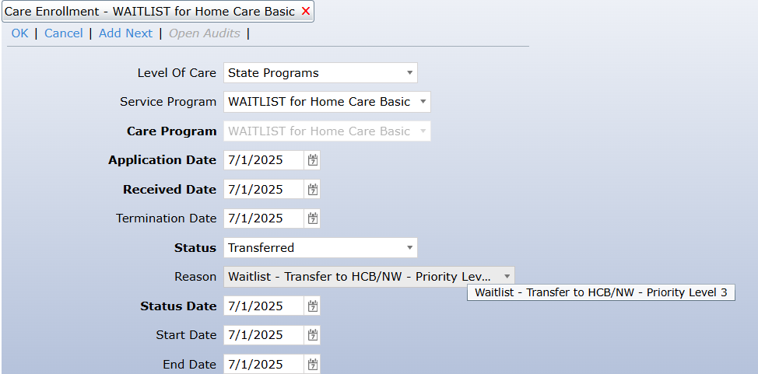

*Notice: If a consumer is found to be eligible to enroll directly into a Home Care program after intake, the start and end dates of the Waitlist Enrollment are the same.

Example of a Waitlist enrollment with status of Waiting (only applicable when a Managed Intake waitlist is enacted):

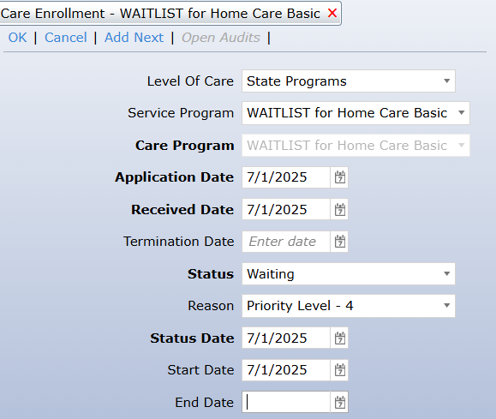

Home Care Program Priority Level Assignment and Waitlist Enrollment Tracking - Statuses and Status Reasons:

Waiting
Waiting Status: An applicant has been assessed as a Priority Level based on the criteria set forth in PI-25-05 Priority Level Assignment Process and Managed Intake.

Applicants only have a Care enrollment in Waiting status if they have been assigned a Priority Level that meets a currently implemented managed intake waitlist.
Status | Status Reason | Definition
Waiting | Priority Level - 1 | Applicant has been determined as a Priority 1 following Managed Intake Phone Screening.
Waiting | Priority Level - 2 | Applicant has been determined as a Priority 2 following Managed Intake Phone Screening.
Waiting | Priority Level - 3 | Applicant has been determined as a Priority 3 following Managed Intake Phone Screening.
Waiting | Priority Level - 4 | Applicant has been determined as a Priority 4 following Managed Intake Phone Screening.

Transferred

Transferred Status: An Applicant has completed the intake process, including having an initial assessment completed and is found to be eligible for Home Care Program Enrollment and are found to be a priority level not subjected to managed intake (if there is an active managed intake directed by AGE).

Status | Status Reason | Definition
Transferred | Waitlist - Transfer to HCB/NW - Priority Level 1 | Applicant assessed and confirmed as Priority Level 1. Financial eligibility assessment confirmed Applicant is Home Care Basic / Non-Waiver
Transferred | Waitlist - Transfer to HCB/NW - Priority Level 2 | Applicant assessed and confirmed as Priority Level 2. Financial eligibility assessment confirmed Applicant is Home Care Basic / Non-Waiver
Transferred | Waitlist - Transfer to HCB/NW - Priority Level 3 | Applicant assessed and confirmed as Priority Level 3. Financial eligibility assessment confirmed Applicant is Home Care Basic / Non-Waiver
Transferred | Waitlist - Transfer to HCB/NW - Priority Level 4 | Applicant assessed and confirmed as Priority Level 4. Financial eligibility assessment confirmed Applicant is Home Care Basic / Non-Waiver
Transferred | Waitlist - Transfer to HCB / PB - Priority Level 1 | Applicant assessed and confirmed as Priority Level 1. Financial eligibility assessment confirmed Applicant is Home Care / Percent Based
Transferred | Waitlist - Transfer to HCB / PB - Priority Level 2 | Applicant assessed and confirmed as Priority Level 2. Financial eligibility assessment confirmed Applicant is Home Care / Percent Based
Transferred | Waitlist - Transfer to HCB / PB - Priority Level 3 | Applicant assessed and confirmed as Priority Level 3. Financial eligibility assessment confirmed Applicant is Home Care / Percent Based
Transferred | Waitlist - Transfer to HCB / PB - Priority Level 4 | Applicant assessed and confirmed as Priority Level 4. Financial eligibility assessment confirmed Applicant is Home Care / Percent Based
Transferred | Waitlist - Transfer to HCB/W - Exception | Applicant assessed and confirmed via MMIS to be enrolled in Frail Elder Waiver. Applicant meets exception to intake policy and will enroll based on service plan cost.
Transferred | Waitlist - Transfer to Choices / Waiver – Exception | Applicant assessed and confirmed via MMIS to be enrolled in Frail Elder Waiver. Applicant meets exception to intake policy and will enroll based on service plan cost.
Transferred | Waitlist - Transfer to ECOP - Exception | Applicant assessed and confirmed as ECOP eligible and will immediately enroll in ECOP (meaning agency has a slot for the consumer). Clinical eligibility, service plan level, and financial eligibility assessment confirmed Applicant is ECOP / Non-Waiver level of care
Transferred | Waitlist - Transfer to HCB/NW – SNF Exception | Applicant assessed and confirmed discharge from nursing facilities and hospitals, including chronic and rehabilitation hospitals, who need Home Care Program Services in order to return to the community.
Transferred | Waitlist - Transfer to HCB/NW – Hospice Exception | Applicant assessed and confirmed to be enrolled in hospice care and who require Home Care Program Services.
Transferred | Waitlist - Transfer to HCB/NW – At Risk Exception | Applicant that is active, or triaged Protective Services consumers, in need of Home Care Program Services
Transferred | Waitlist - Transfer to HCB/ PB – SNF Exception | Applicant assessed and confirmed discharge from nursing facilities and hospitals, including chronic and rehabilitation hospitals, who need Home Care Program Services in order to return to the community
Transferred | Waitlist - Transfer to HCB/ PB – Hospice Exception | Applicant assessed and confirmed to be enrolled in hospice care and who require Home Care Program Services.
Transferred | Waitlist - Transfer to HCB/ PB – At Risk Exception | Applicant that is active, or triaged Protective Services consumers, in need of Home Care Program Services

Terminated

Terminated Status: An Applicant has initiated the intake process, but will not be moving forward and enrolling into a Home Care Program

 | Status | Status Reason | Definition
Terminated |  | Withdrawn from WAITLIST – Adequate Formal Support | Applicant is receiving formal support and no longer has unmet needs to be addressed by the Home Care program.
Terminated |  | Withdrawn from WAITLIST – Adequate Informal Support | Applicant is receiving informal support and no longer has unmet needs to be addressed by the Home Care program.
Terminated |  | Withdrawn from WAITLIST – Death | Applicant passed away prior to enrolling into Home Care program.
Terminated |  | Withdrawn from WAITLIST – FIL Ineligibility | Applicant assessed in person and determined to not meet FIL eligibility levels at this time.
Terminated |  | Withdrawn from WAITLIST – Moved from Service Area | Applicant has moved from the ASAP service area. If Applicant is continuing to pursue ASAP services, warm transfer should be initiated to new ASAP based on geographic location.
Terminated |  | Withdrawn from WAITLIST – Nursing Facility Admission | Applicant has been admitted to the nursing facility and does not have a tentative discharge date.
Terminated |  | Withdrawn from WAITLIST – Other Reason | Applicant’s reason for Termination does not fall into the above categories. Reason for termination must be well documented in a journal entry.
Status |  | Status Reason | Definition

Reporting:
To ensure accurate reporting statewide, ASAPs are required to monitor data entry and reconcile data no less than monthly.

ASAPs must have a clearly defined process for generating reports, reviewing and correcting data, and retraining staff as needed, including those staff who are responsible for each component of the process.

ASAPS will utilize the following HAR report to track current waitlist enrollment status and data validation: Home Care Managed Intake Monitoring.

ASAPs must run this HAR report, review, and correct inaccuracies monthly to ensure that all consumers are assessed a priority level and have a waitlist enrollment entered accordingly.

Report Monitoring and Reconciliation:
• ASAP – Monthly

The ASAP is responsible for identifying a comprehensive process for report generation, data entry validation, correction, and staff responsible. Components of the process should include:

• generating reports
• reviewing for quality assurance,
• identifying inaccuracy trends,
• addressing inaccuracies, and
• completing necessary follow-up within a timely manner

All follow-up actions completed by the ASAP must be documented in the consumer’s A&D record as appropriate.

AGE requires the HAR report, Home Care Managed Intake Monitoring, to be run monthly. See user guide for additional details.

If you have questions regarding this Business Rule, contact Home Care Program Coordinator, Shannon K. Turner at Shannon.K.Turner@Mass.Gov.

